Practical-4

1.Echo: Output any text that we provide.

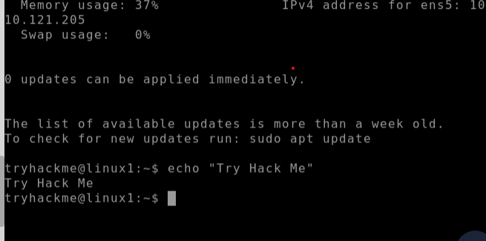

2.whoami : Find out what user we're currently logged in as!:

3.Listing Files in Our Current Directory (ls):

*Before we can do anything such as finding out the contents of any files or folders, we need to know what exists in the first place. This can be done using the "ls" command (short for listing)*

4.Add new directories using **mkdir** command:

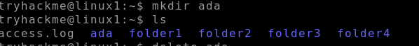

5.Removing directories using **rmdir** command:

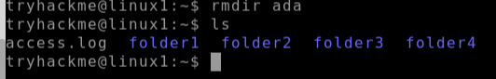

6.Read the contents of file using **CAT** command:

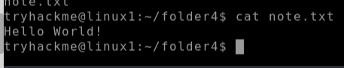

7.Know all related commands using **man (function/command name):**

